Strengthen Your Core Safely

Curl-up With Knee Bent

- Hands are under your head to support (not pull) your head and neck during the full motion.
- One leg is bent to 90 degrees while the other leg remains relaxed straight on the floor.
- Push your lower back towards the floor. You want your lower back to remain pinned to the floor while you perform the exercise.
- Picture your head and neck as a rigid block on your mid back. No neck motion should occur during this exercise.
- Elevate your head, neck, and shoulders off the floor until your shoulder blades are off the floor while performing abdominal bracing.
- Hold for at least 1 full second and then go back down slowly (Perform same amount of reps on each leg).
- Key Focus- rotation of this movement should be focused in your mid back region.

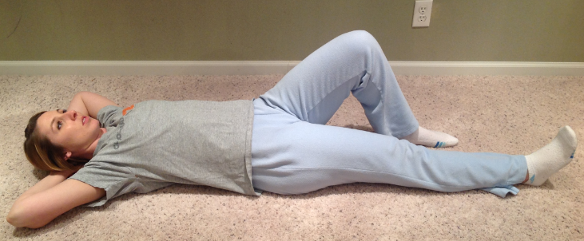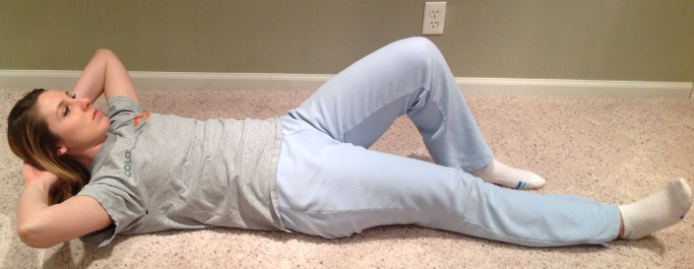

Cross-knee Curl Up Modified

- One leg is bent to 90 degrees while the other leg remains relaxed on the floor.
- The opposite elbow of the bent knee is bent while the other arm lays straight on the floor.
- Push your lower back towards the floor. You want your lower back to remain pinned to the floor while you perform the exercise.
- Bring your bent elbow and bent knee towards each other while performing abdominal bracing.
- Hold for at least 1 second and bring them back down slowly.
- Do not try to touch your elbow and knee together because if you do you are putting too much torque on your back.
- You can also bring leg straight out just off the floor for more of a challenge.
- Perform the same amount of reps on each side.

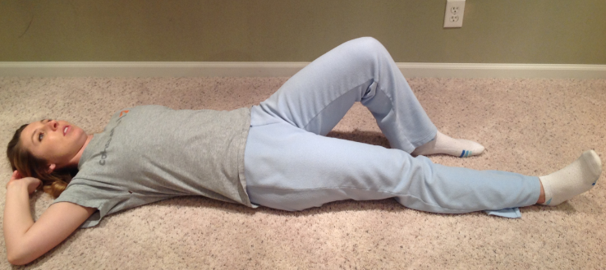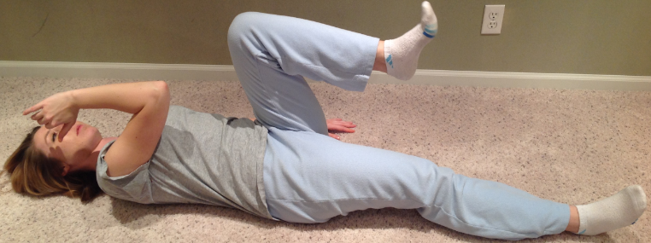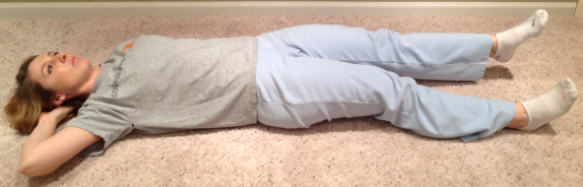

Side Lying Elbow to Knee

- Lay on your side with both legs straight and support your head and neck with your bottom hand.
- Bend your top elbow.
- Bring your top knee in a bent position and top elbow together (or close together) and hold for at least 1 second while abdominally bracing.
- Do not move your head or neck while performing the motion.
- Bring your elbow and leg back to starting position slowly.
- Perform the same amount of reps on each side.

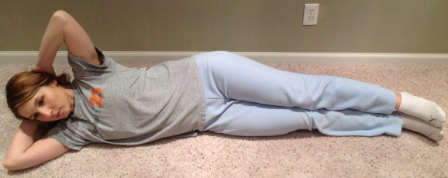
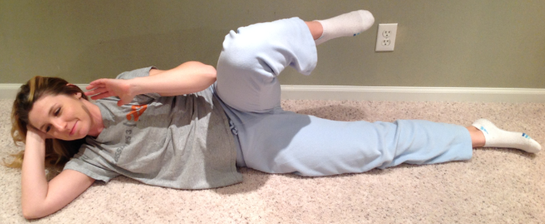

Planks

- Begin in the plank position with your forearms and toes on the floor.
- Elbows and shoulders should make a straight line.
- Keep your torso straight and rigid and your body in a straight line from ears to toes with no sagging or bending.
- Your head is relaxed and you should be looking at the floor while you are abdominally bracing.
- Hold this position for at least 10 seconds.
- Over time work up to 30, 45 or 60 seconds.

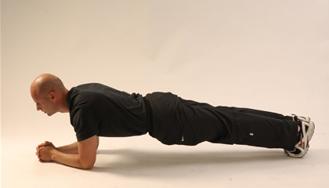

Birddog

Beginners
- Begin on all fours, knees hip-width apart and under the hips, hands flat and shoulder-width apart.
- Perform abdominal bracing.
- Keep the spine neutral, without arching the back or rotating the hips, and extend one leg or arm at a time.
- Hold for at least 2-3 second and then go back to starting position.
- Perform the same amount of reps on each side.

Advanced
- Raise your opposite arm and leg straight out simultaneously.
- Raising either arm or leg past horizontal should be avoided.
- Hold limbs parallel to the floor for at least 2-3 seconds and then back to starting position.
- Perform the same amount of reps on each side.

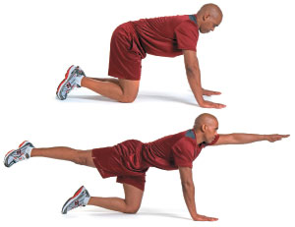

Vernon Place Preventative Health Chiropractic Clinic
6301 Antioch Road Merriam, KS 66202 Office number: (913) 839-7352 www.vpphcc.com
Dr. Cole J. Stephens D.C. Specialist in Postural Correction and Nutritional Wellness

Key Points to Know When You are Lifting Weights
- Spine should be in a straight neutral position with all lifting exercises (including yourself).

- Avoid hyperflexion (extreme forward bending) and hyperextension (extreme backward bending) exercises.

- Avoid twisting exercises.

- Avoid exercises that require spinal flexion or bending just after rising from bed (1-2 hrs) because it leads to elevated tissue stresses on the ligaments and discs.

- Lift weights as much as possible unilaterally and not bilaterally.

- Utilize dumbbells (free weights) and exercise bands for any exercise muscle group you are trying to work out and avoid as much as possible weight bars and exercise machines.

- Avoid weight bars and other objects on your back.

- Pick up weights with your legs and not your back.

- Never sacrifice form for lifting more weight.

